**Play Neapolitan tombola**

**LEARN TO READ AND MAKE SIMPLE CALCULATIONS**

**The story**

Neapolitan tombola was born in 1734 in the Kingdom of Naples due to a discussion between King Charles III of Bourbon and the Dominican friar Gregorio Maria Rocco.

King Charles III wanted to make the lottery game official in the Kingdom because, if it had remained clandestine, it would have stolen money from the State. Father Rocco, on the other hand, believed that the lottery game was moralless and a deceptive pleasure for his faithful.

In the end the king won, but on the condition that during the week of the Christmas holidays the game was suspended so that the people should not be distracted from prayers.

The people didn't want to give up playing and organized themselves in another way. How? The ninety lottery numbers were enclosed in a wicker "panariello" and the numbers were drawn on folders, thus the popular imagination transformed a public game into a family game.

The name tombola derives from the cylindrical shape of the piece of wood where the number is written and from the noise that the number makes when it falls from the small panaro onto the table. The game's ninety numbers were given different meanings, which changed from region to region. The meanings of Neapolitan tombola are almost all allusive and sometimes scurrilous, that is, vulgar.

**The rules**

The game of bingo is the same as bingo. Bingo is a game in which participants must pay a sum of money which is then redistributed as a prize to the winners.

Italian tombola is normally played as a family (it is a traditional Christmas game). The sums that are pledged and won have symbolic values (even if you do not choose to use prizes of another nature). The random nature of the game together with a considerable value of the prizes up for grabs has made the term tombola synonymous with a lucky event or the fortuitous acquisition of wealth or a sum of money.

A player with the role of croupier has at his disposal a board on which all the numbers from 1 to 90 are shown, and a cup or bag filled with similarly numbered pieces. The croupier's job is to draw the pieces randomly and announce the number that comes out to the other players. The announcement generally also includes the citation of one of the images that the traditional Neapolitan grimace associates with the numbers from 1 to 90 typical of another game, the lottery, closely linked to tombola. Players have one or more previously purchased cards, made up of 3 rows, on each of which there are five numbers between 1 and 90.

Every time the drawn number is present on one or more of his cards, the player "covers" the corresponding square. In the traditional version of bingo. The folders are simple printed cards and the numbers are covered with beans, chickpeas, lentils, pasta or other material available after large Christmas dinners (dinners) such as dried fruit shells.

The cards are made in groups of six so that in each group the numbers from 1 to 90 occur once and only once.

The cards are purchased in variable numbers by players according to a predefined unit price. Similarly, the player who takes the board pays the amount relating to the six virtual cards that make up the board. It is possible, as a variation to the classic rules, and with general agreement, that the board is purchased by the croupier in partial form. It is also possible that an additional payment will be made for the board to compensate for the fact that all the numbers drawn are always placed on the board. The amount resulting from the purchase of all the cards and the scoreboard defines the prize pool which is divided into various prizes of increasing amounts. The ultimate aim of the game is to play the tombola, that is, to be the first to cover all the numbers on one of your cards. Minor prizes are also awarded for intermediate results, such as the ambo (won by the first player to cover two numbers on the same row of a card), the terno (three numbers on the same row), the quaterna (four numbers on the same row), the cinquina (all five numbers on the row).

Sometimes a prize is also awarded to the so-called tombolino, i.e. the second card in order of time to score the tombola. A further rule states that anyone who wins a prize on one row cannot win the next prize on the same row of the same card. So whoever does an ambo on the first row cannot do a triple on the first, but only on the second or third, but can still do a quad on the first row. This rule has the aim of distributing the prizes more evenly (consistent with the fact that tombola is intended as a game of aggregation, in which children often also participate).

However, the most popular interpretation establishes that the terno, quaterna and cinque can be performed on the same row, to allow for more ex aequo winnings.

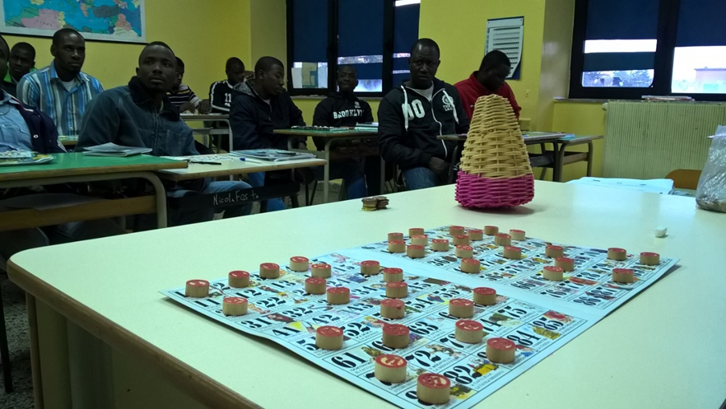

Cpia di Montesarchio - Dicembre 2016-

**Descrivi sinteticamente la tua esperienza vissuta giocando alla tombola napoletana a scuola**

Quando si gioca a tombola ?

Qual é il nome con cui viene chiamata la tombola ?

Quali caratteristiche ha la tombola napoletana ?

Per quanto tempo e quante volte avete giocato a tombola ?

Quali persone hanno fatto ambo terno quaterna etc. ?

**PER IL DOCENTE** : VEDERE ALLEGATO TABELLA PRESENTAZIONI NUMERI PER ESERCITARSI NEI CALCOLI A MENTE